**CS 570 Software Testing**

# HOP01D – Java Extension Pack in VSCode

1/31/2019 Developed by Sam Chung

4/16/2019 Tested by Jin Chang

School of Technology & Computing (STC)

City University of Seattle (CityU)

**Caution**

* If you already finished this module through any CityU Technology Institute (TI) courses,  
  just skim this module and skip it.
* Some version numbers may not match with the newly released ones.  
  If so, stay with the most recent ones.
* We target Windows OS. So, Mac may have different options.
* We cannot explain every steps. This cookbook always needs your own creative judgement.

**Learning Outcomes**

* Learn how to install Java Extension Pack into your VSCode.
* Learn how to write and run a simple “Hello, your_first_name” program in Java with Visual Studio Code.
* Learn how to conduct the threat modeling of your hello world application.

**References**

* Writing Java with Visual Studio Code  
  <https://code.visualstudio.com/docs/java/java-tutorial>
* To help set up Java on VS Code, there is the Microsoft [Java Extension Pack](https://marketplace.visualstudio.com/items?itemName=vscjava.vscode-java-pack), which contains these popular extensions:

1. Language Support for Java(TM) by Red Hat
2. Debugger for Java
3. Java Test Runner
4. Maven for Java
5. Java Dependency Viewer

**Install Java Extension Pack**

1. Visit Java Extension Pack at <https://marketplace.visualstudio.com/items?itemName=vscjava.vscode-java-pack>

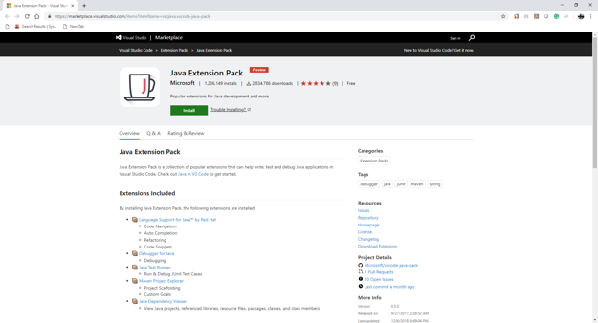

1. Install Java Extension Pack.

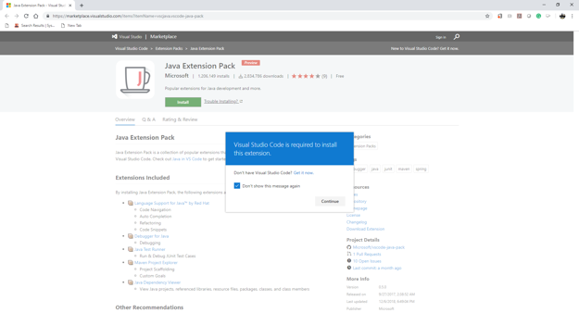

1. Press the “install” button.

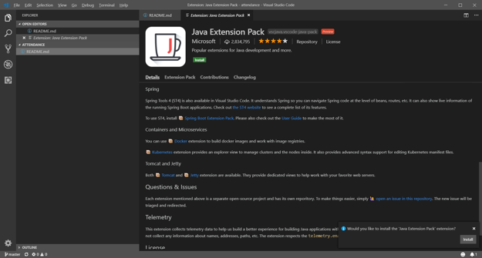

**Implementing “Hello, your_first_name”**

1. Open your terminal in your VSCode by selecting “New Terminal: from “Terminal” menu item.

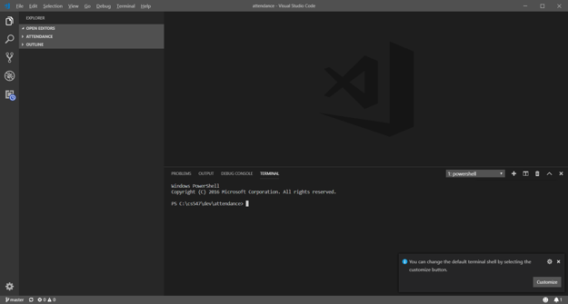

1. Move to your working directory, “csXYZ/module01” and then create a directory called “java_in_vscode” (csXYZ means your course number. Create a module01 under the course directory.)
2. Open the “java_in_vscode’ folder.

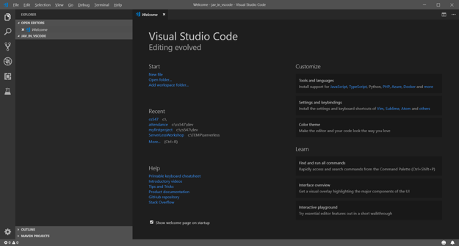

1. Create a Java file called “Hello.java”

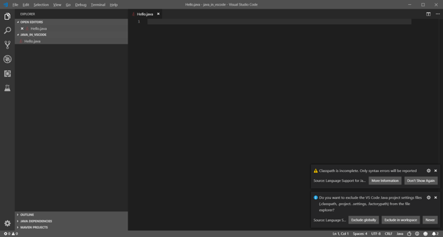

1. Enter the code at <https://code.visualstudio.com/docs/java/java-tutorial>

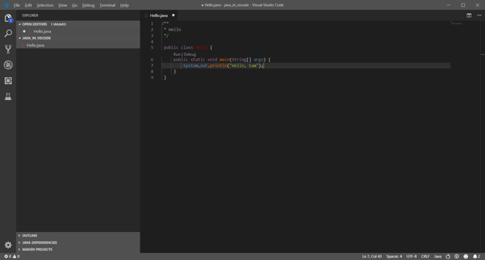

1. By pressing the “Run” tab, please execute your “Hello.java” program.

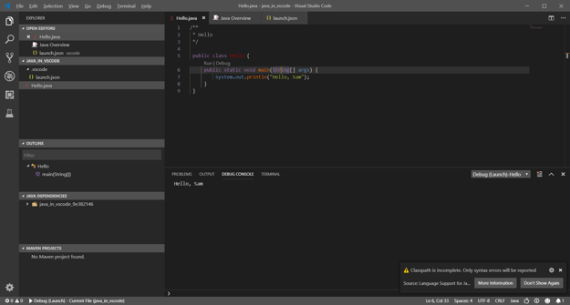

**Questions:**Answer each question.   
Show a good reference(s) to support your answer.

1. Why do we need to use Java Extension Pack?   
   (Answer)